Healthcare Call Center Performance Analysis
SQL | Power Query | Power BI | Python
California Healthcare Call Center Data, January-June 2026
Contents
Project Overview 2
Business Questions 2
Data & Methodology 2
SQL Analysis 3
Data Cleaning and Validation 3
Dataset Integration 3
Overall Performance 3
Monthly Performance 3
Python Analysis 3
Relationship between wait time and abandonment 4
Adjusted Regression Analysis 4
High-Abandonment Profile 5
County and Monthly Patterns 6
County Performance 6
Operational Risk Analysis 7
Wait Time & Abandonment Analysis 8
Power BI Dashboard 8
Key Findings 8
Overall Performance 8
Monthly Performance 8
County Performance 8
Operational Risk 8
Wait Time 9
Business Insights 9
Recommendations 9

Project Overview
The project analyzes healthcare call-center performance across California counties using three data sets covering January – June 2026. SQL was used for cleaning, integration, validation, and analysis. Power Query prepared the data for Power BI, and Power BI was used to communicate the results.

Business Questions
This analysis aims to answer the following questions:
- How many calls were handled?
- How did call volume, wait time, and abandonment change over time?
- Which counties had the longest wait times?
- Which counties had the highest abandonment?
- How does abandonment vary by wait-time level?
- Which counties experienced both high volume and high abandonment?
- Which counties should be considered high priority?
- Which counties improved between January and June?

Data & Methodology
Dataset | Key Fields
Call Volume | Reporting Period, County Name, Total Call Volume
Average Wait Time | Reporting Period, County Name, Average Wait Time
Average Abandonment Rate | Reporting Period, County Name, Average Abandonment Rate

The three source datasets were cleaned and validated in SQL, then joined by reporting month and county to create a consolidated healthcare call-center dataset. The resulting dataset was used for county-level and monthly performance analysis before being prepared for Power BI visualization.

SQL Analysis

Data Cleaning and Validation
The three source tables were validated before analysis to confirm the number of call records. Row-count validation returned 205 records for the call-volume dataset, 204 for average wait time, and 205 for average abandonment rate.

Dataset Integration
The three analysis tables were joined using month and county name to create a master healthcare call-center dataset containing total calls, average abandonment rate, and average wait time. During validation, a discrepancy was identified between the overall abandonment rate calculated in SQL (24.11%) and the Power BI result (27%). The difference occurred from the calculation methods: SQL calculated the overall rate using the source abandonment-rate data, while Power BI averaged county-month abandonment percentages.

Overall Performance
Across the six-month analysis period, the healthcare call center handled approximately 9.56 million calls, with an average wait time of 32.87 minutes and an average abandonment rate of 24.11%.

Monthly Performance
Month | Total Calls | Average Wait | Average Abandonment
January | 1, 759, 226 | 41.56 | 27.76%
February | 1, 532, 545 | 34.66 | 24.88%
March | 1, 660, 271 | 32.08 | 24.42%
April | 1, 609, 932 | 30.54 | 22.85%
May | 1, 425, 221 | 29.23 | 22.36%
June | 1, 572, 554 | 29.17 | 22.27%

Python Analysis
After identifying a clear relationship between wait time and abandonment in SQL, Python was used to further investigate and quantify the relationship. The goal was to determine whether the observed pattern represented a measurable statistical relationship and whether wait time remained related to abandonment after accounting for call volume, county, and month.

Relationship between wait time and abandonment
A correlation analysis and scatterplot were used to quantify the relationship between average wait time and abandonment rate.
- Correlation coefficient: 0.603
- This indicates a positive relationship between average wait time and abandonment rate.
- The scatterplot shows that observations with longer wait times generally tend to have higher abandonment rates.
This supported the initial SQL finding that abandonment increased substantially across higher wait-time categories.
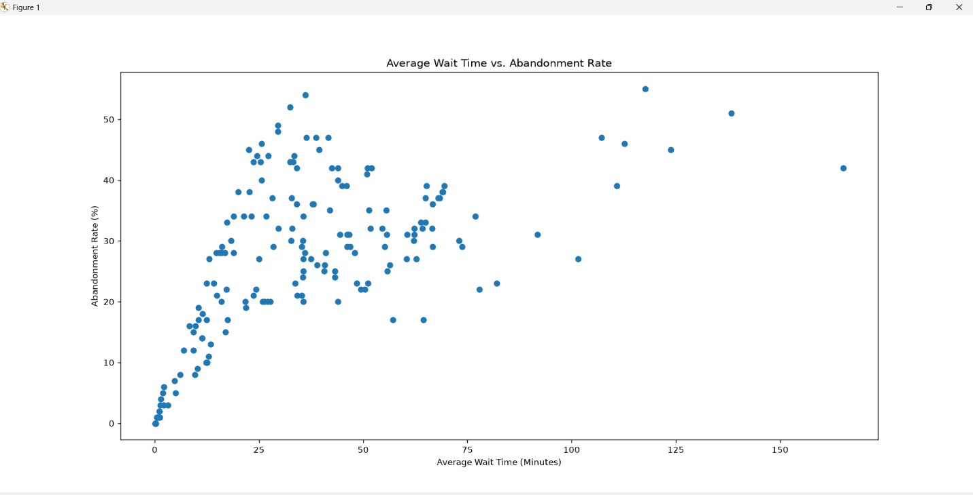

Adjusted Regression Analysis
To determine whether the relationship between wait time and abandonment continued after accounting for other factors, an OLS regression was estimated with:
- Wait time
- Call volume
- County
- Month
as explanatory variables.
The model found that wait time remained positively related to abandonment after controlling for call volume, county, and month.
- Wait-time coefficient: 0.0758
- p-value: 0.017
Because the p-value was below 0.05, the relationship between wait time and abandonment remained statistically significant after accounting for the other variables in the model.
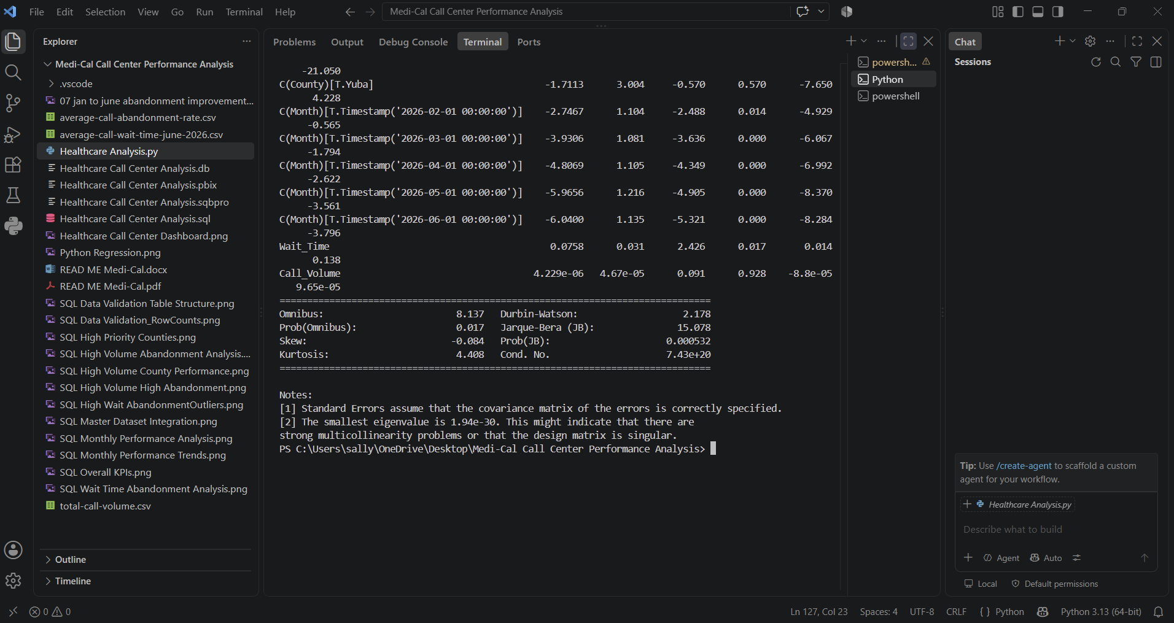
This strengthened the SQL finding by showing that the relationship between wait time and abandonment rate persisted after accounting for differences in call volume, county, or month.

High-Abandonment Profile
Python was used to examine observations with high abandonment rates and compare their characteristics. High abandonment observations had higher wait times and call volumes in comparison to the lower abandonment group.
Metric | Lower Abandonment | High Abandonment
Mean wait time | 2.03 minutes | 38.19 minutes
Median wait time | 1.52 minutes | 34.69 minutes
Mean call volume | 1,577 | 54,685
Median call volume | 180 | 31,125

This provided more evidence to show that high abandonment observations were associated with longer waits and greater call volume.
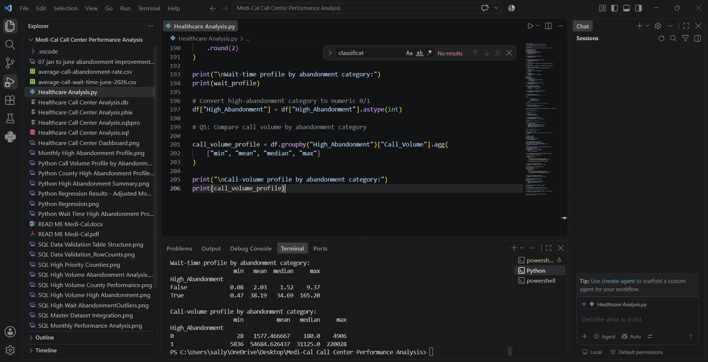

County and Monthly Patterns
Python was also used to examine whether high-abandonment observations were concentrated in specific counties or months.
Across the six-month period, 29 of 34 county-month observations were classified as high abandonment in each month, representing 85.3% of observations. The monthly profile was therefore consistent across January through June rather than showing a single month driving the high-abandonment classification.
At the county level, the high-abandonment classification was concentrated in most counties, while a smaller group of counties consistently fell outside the classification.
These results provide additional context for the SQL analysis by showing that the high-abandonment pattern was observed consistently across all six months and across multiple counties, rather than being isolated to a single period or location.

County Performance
Highest Call Volume
- Los Angeles: 1.15 million calls
- Sacramento: 915,000 calls
- Orange: 882,000 calls

Highest Average Wait Time
- Tulare: 118.41 minutes
- Orange: 76.67 minutes
- Santa Barbara: 68.07 minutes
- Sacramento: 67.13 minutes
- Kern: 63.98 minutes
Los Angeles handled the highest call volume, while Tulare experienced the longest average wait time, highlighting differences between demand volume and service performance across counties.

Operational Risk Analysis
High-Volume / High-Abandonment Counties
The analysis identified counties experiencing both high call volume and high abandonment rates, highlighting areas where high demand may coincide with caller loss.
High-Priority County Criteria
Counties were classified as high priority when they met all three conditions:
- At least 250,000 calls
- Average wait time of at least 40 minutes
- Average abandonment rate of at least 30%
High-Priority Counties
- Tulare
- Los Angeles
- Kern
- Sacramento
These counties met the combined performance thresholds and were identified as areas of elevated operational pressure.

Wait Time & Abandonment Analysis
Wait Time | Average Abandonment
Under 15 minutes | 6.25%
15-29 minutes | 31.03%
30-59 minutes | 32.49%
60+ minutes | 34.69%

Abandonment increased substantially as wait times increased, with observations under 15 minutes having a 6.25% average abandonment rate compared with 34.69% among observations with wait times of 60 minutes or more.

Power BI Dashboard
Power BI was used to communicate the analysis through KPI cards and interactive visualizations showing total call volume, average wait time, abandonment rate, monthly call trends, and county-level performance. The dashboard enables users to quickly identify changes over time and counties experiencing elevated operational pressure.

Key Findings

Overall Performance
- 9.56M calls across January–June 2026
- 32.87-minute average wait
- 24.11% average abandonment

Monthly Performance
- January had the highest call volume.
- Average wait declined from 41.56 minutes in January to 29.17 minutes in June.
- Average abandonment declined from 27.76% to 22.27%.

County Performance
- Los Angeles had the highest total call volume.
- Tulare had the highest average wait time and abandonment rate.
- Several counties experienced both high demand and poor service outcomes.

Operational Risk
- Tulare, Los Angeles, Kern, and Sacramento met the high-priority criteria.

Wait Time
- Abandonment increased substantially as wait-time levels increased.

Business Insights
Service performance improved gradually over time. Average wait time declined from 41.56 minutes in January to 29.17 minutes in June, while the average abandonment rate declined from 27.76% to 22.27%.
Performance varied across the counties. Los Angeles handled the highest call volume at approximately 1.15 million calls, while Tulare experienced a severe combination of demand and service performance, with 266,283 calls, an average wait time of 118.41 minutes, and a 47.17% abandonment rate.
Average wait time and abandonment rate have a positive relationship with a correlation coefficient of 0.603. Further regression analysis showed that wait time remained significantly associated with abandonment after accounting for call volume, county, and month, resulting in a p-value of 0.017. County-month observations with average wait times of 60 minutes or more had a 34.69% average abandonment rate, compared with 6.25% among observations with wait times under 15 minutes. This suggests that excessive wait times may be an important factor to consider when evaluating caller retention.
Several counties showed high operational pressure. Tulare, Los Angeles, Kern, and Sacramento met the project's combined thresholds for call volume, average wait time, and abandonment rate, identifying them as priority areas for further operational review.

Recommendations
Optimize staffing during periods of higher demand. January experienced the highest call volume, average wait time, and abandonment rate during the analysis period. Call centers could use historical demand patterns to anticipate higher-volume periods and adjust staffing levels, accordingly, helping increase available capacity and potentially reduce wait times and caller abandonment.
Prioritize counties experiencing elevated operational pressure. Focus operational review and resource allocation on Tulare, Los Angeles, Kern, and Sacramento, which met the project's combined thresholds for high call volume, wait time, and abandonment.
Monitor wait time and abandonment together. Because abandonment rates were substantially higher among observations with longer wait times, these metrics should be monitored together when evaluating call-center performance and identifying areas requiring operational attention.

